One submission per group (2 students) **SE185: Problem Solving in Software Engineering**

**Quiz # 6 (100 points)**

|  |  |
| --- | --- |
| Name: Miles Nichols | Name: |

Answer the following questions and make a pdf file that includes the **source code, sample inputs, and outputs**. You must submit the **pdf file and all of the .c files** on Canvas for full credit. Do not forget to add your group partner name on the pdf file and the source codes.

**1. (100 points)** Write a complete C code that scans a **first** and **last name** into **two separate char arrays** whose memory is **statically allocated**. Your program must put the first and last names together, separated by a space, into a single string (not the char arrays used for the first/last names). Your program must **use the strlen() function** to **dynamically allocate memory** to a **char pointer** which will serve as your final string.

Use a loop to iterate through your final string (char pointer) and count only the number of letters (no spaces, null characters, or other symbols). **Use pointer notation** instead of array notation. Your program must use **malloc() and free().**

Begin by creating these variables **(use these variable names)**:

char first_name[50], last_name[50]; char *full_name = NULL; int num_letters = 0;

**Inputs and outputs format:**

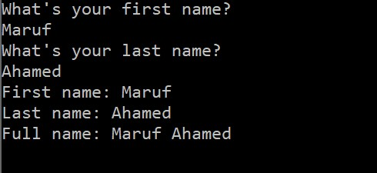

Compile

code

